**Implicit Drill Down in Visuals**

**\*\*\*\*Even if explicitly hierarchy is not created in the table still, we can get its effect in the visuals.\*\*\*\***

1. Place a Bar Chart
2. In the Axis field, add Country at the top, followed by State, and then City.

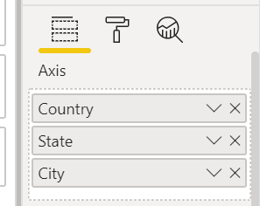

1. Place Sales_Amt in value
2. To enable Drill Down
   1. Click on the ↓icon (it’s a toggle)

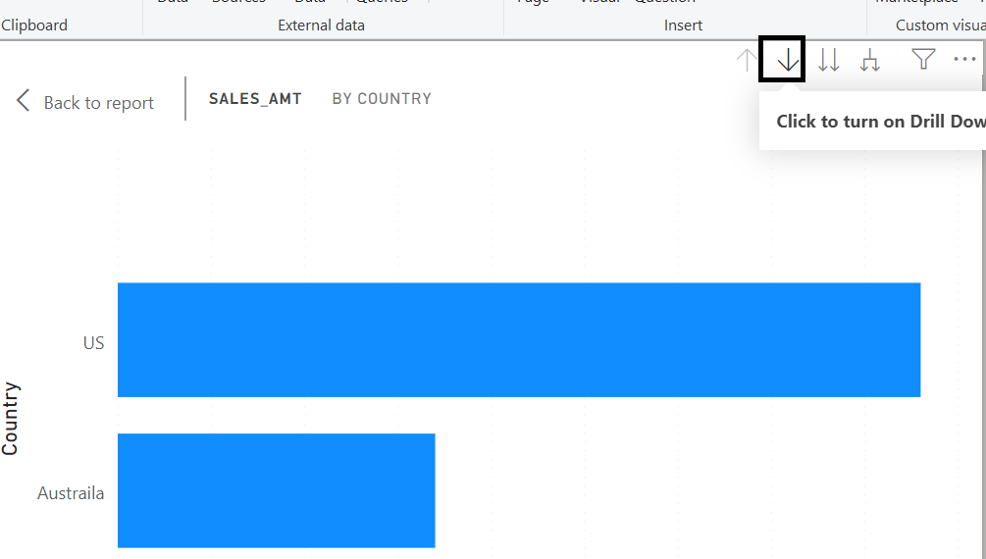

* 1. The drill down functionality gets enabled

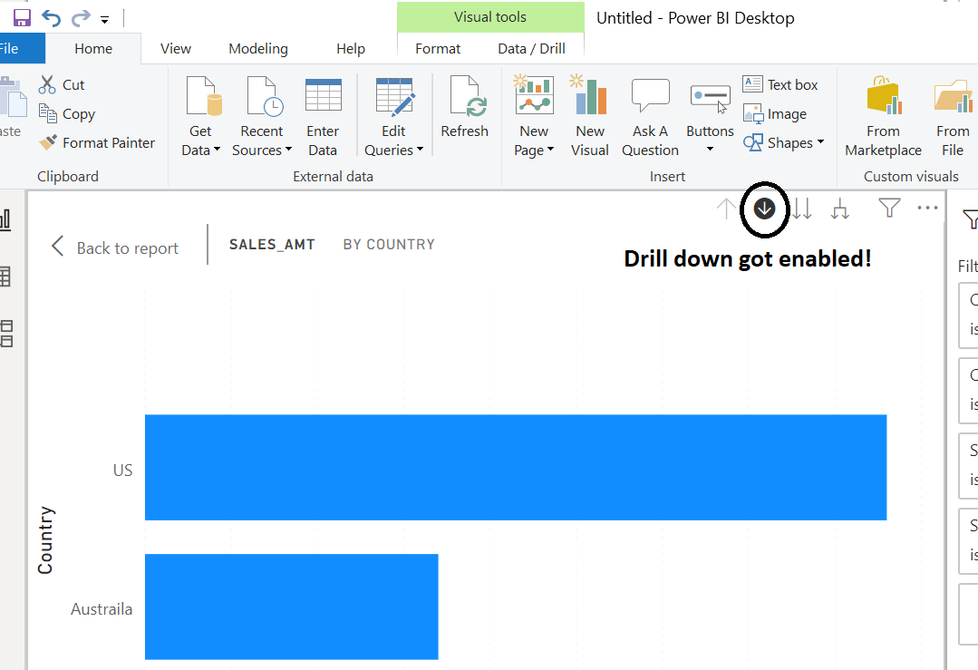

* 1. Now click on the US bar. It shows the states of US

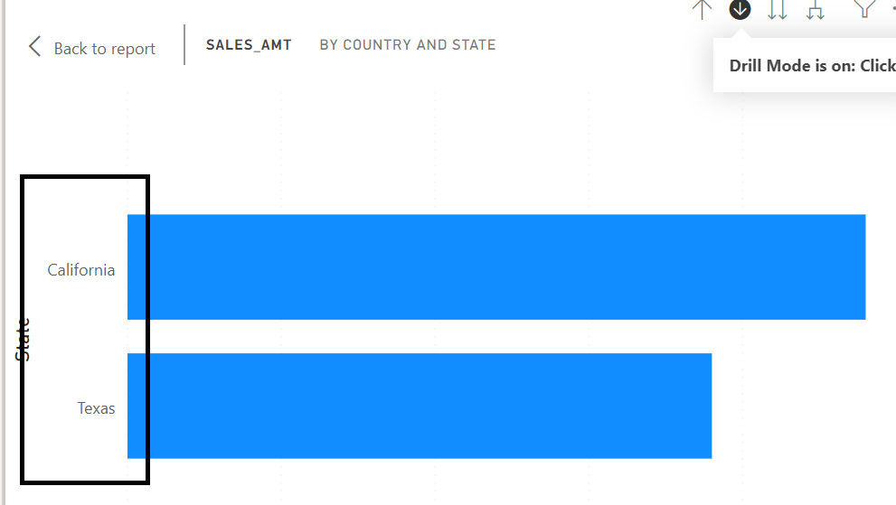

* 1. Then click on the California bar.
  2. Now, it shows all the cities within California only.

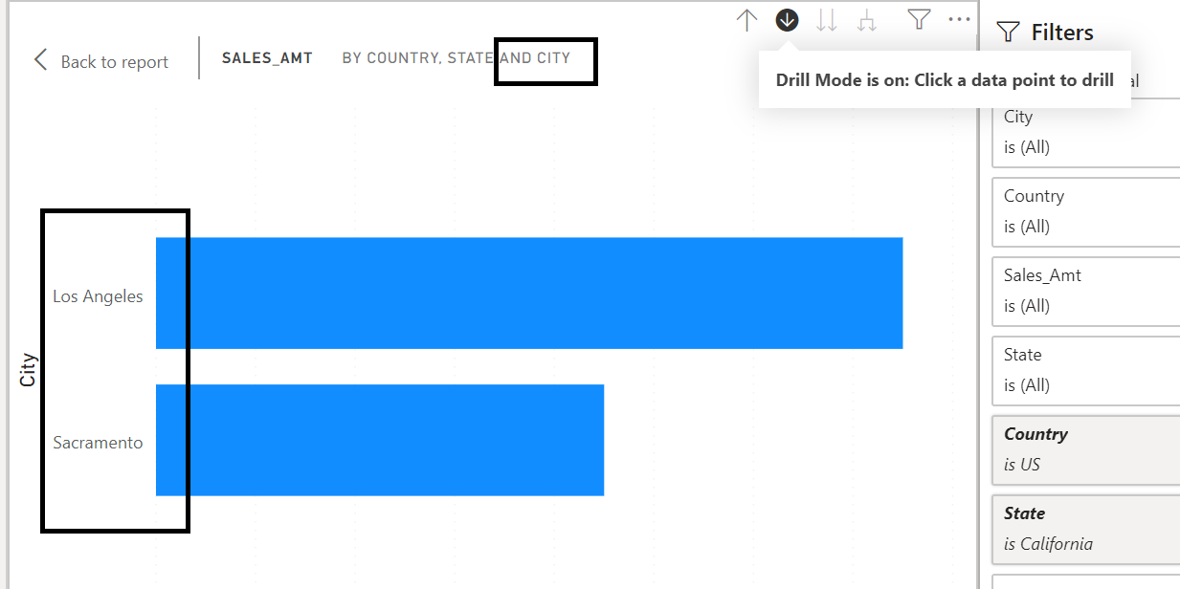

* 1. To move up the ladder go on clicking the ↑icon.